EINSATZGRUPPEN (MOBILE KILLING UNITS)
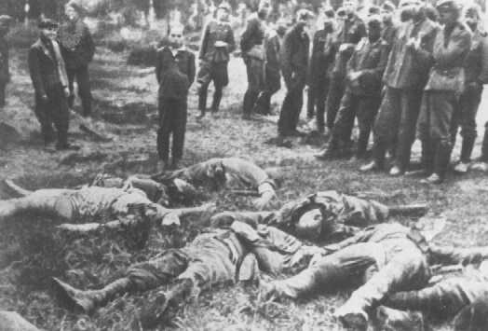
Members of an Einsatzkommando (mobile killing squad) before shooting a Jewish youth. The boy's murdered family lies in front of him; the men to the left are ethnic Germans aiding the squad. Slarow, Soviet Union, July 4, 1941.
— Dokumentationsarchiv des Oesterreichischen Widerstandes

Einsatzgruppen (in this context, mobile killing units) were squads composed primarily of German SS and police personnel. Under the command of the German Security Police (Sicherheitspolizei; Sipo) and Security Service (Sicherheitsdienst; SD) officers, the Einsatzgruppen had among their tasks the murder of those perceived to be racial or political enemies found behind German combat lines in the occupied Soviet Union.

These victims included Jews, Roma (Gypsies), and officials of the Soviet state and the Soviet Communist party. The Einsatzgruppen also murdered thousands of residents of institutions for the mentally and physically disabled. Many scholars believe that the systematic killing of Jews in the occupied Soviet Union by Einsatzgruppen and Order Police (Ordnungspolizei) battalions was the first step of the "Final Solution," the Nazi program to murder all European Jews.

During the invasion of the Soviet Union in June 1941, the Einsatzgruppen followed the German army as it advanced deep into Soviet territory. The Einsatzgruppen, often drawing on local civilian and police support, carried out mass-murder operations. In contrast to the methods later instituted of deporting Jews from their own towns and cities or from ghetto settings to killing centers, Einsatzgruppen came directly to the home communities of Jews and massacred them.

The German army provided logistical support to the Einsatzgruppen, including supplies, transportation, housing, and occasionally manpower in the form of units to guard and transport prisoners. At first the Einsatzgruppen shot primarily Jewish men. By late summer 1941, however, wherever the Einsatzgruppen went, they shot Jewish men, women, and children without regard for age or sex, and buried them in mass graves. Often with the help of local informants and interpreters, Jews in a given locality were identified and taken to collection points. Thereafter they were marched or transported by truck to the execution site, where trenches had been prepared. In some cases the captive victims had to dig their own graves. After the victims had handed over their valuables and undressed, men, women, and children were shot, either standing before the open trench, or lying face down in the prepared pit.

Shooting was the most common form of killing used by the Einsatzgruppen. Yet in the late summer of 1941, Heinrich Himmler, noting the psychological burden that mass shootings produced on his men, requested that a more convenient mode of killing be developed. The result was the gas van, a mobile gas chamber surmounted on the chassis of a cargo truck which employed carbon monoxide from the truck's exhaust to kill its victims. Gas vans made their first appearance on the eastern front in late fall 1941, and were eventually utilized, along with shooting, to murder Jews and other victims in most areas where the Einsatzgruppen operated.

The Einsatzgruppen following the German army into the Soviet Union were composed of four battalion-sized operational groups. Einsatzgruppe A fanned out from East Prussia across Lithuania, Latvia, and Estonia toward Leningrad (now St. Petersburg). It massacred Jews in Kovno, Riga, and Vilna. Einsatzgruppe B started from Warsaw in occupied Poland, and fanned out across Belorussia toward Smolensk and Minsk, massacring Jews in Grodno, Minsk, Brest-Litovsk, Slonim, Gomel, and Mogilev, among other places. Einsatzgruppe C began operations from Krakow (Cracow) and fanned out across the western Ukraine toward Kharkov and Rostov-on-Don. Its personnel directed massacres in Lvov, Tarnopol, Zolochev, Kremenets, Kharkov, Zhitomir, and Kiev, where famously in two days in late September 1941 units of Einsatzgruppe detachment 4a massacred 33,771 Kiev Jews in the ravine at Babi Yar. Of the four units, Einsatzgruppe D operated farthest south. Its personnel carried out massacres in the southern Ukraine and the Crimea, especially in Nikolayev, Kherson, Simferopol, Sevastopol, Feodosiya, and in the Krasnodar region.

The Einsatzgruppen received much assistance from German and Axis soldiers, local collaborators, and other SS units. Einsatzgruppen members were drawn from the SS, Waffen SS (military formations of the SS), SD, Sipo, Order Police, and other police units.

By the spring of 1943, the Einsatzgruppen and Order Police battalions had killed over a million Soviet Jews and tens of thousands of Soviet political commissars, partisans, Roma, and institutionalized disabled persons. The mobile killing methods, particularly shooting, proved to be inefficient and psychologically burdensome to the killers. Even as Einsatzgruppen units carried out their operations, the German authorities planned and began construction of special stationary gassing facilities at centralized killing centers in order to murder vast numbers of Jews.

From: http://www.ushmm.org/wlc/en/article.php?ModuleId=10005130

