Station 2- Violence:
Worldwide, more than 700 million women alive today were married as children (below 18 years of age). More than one in three—or some 250 million—were married before 15. Child brides are often unable to effectively negotiate safer sex, leaving themselves vulnerable to sexually transmitted infections, including HIV, along with early pregnancy. The fact that girls are not physically mature enough to give birth, places both mothers and their babies at risk. Poor girls are also 2.5 times more likely to marry in childhood than those living in the wealthiest quintile
Around 120 million girls worldwide (slightly more than 1 in 10) have experienced forced intercourse or other forced sexual acts at some point in their lives
More than 133 million girls and women have experienced some form of female genital mutilation (FGM) in the 29 countries in Africa and the Middle East where the harmful practice is most common. Beyond extreme physical and psychological pain, girls who undergo FGM are at risk of prolonged bleeding, infection (including HIV), infertility, complications during pregnancy and death.
Trafficking ensnares millions of women and girls in modern-day slavery. Women and girls represent 55 per cent of the estimated 20.9 million victims of forced labour worldwide, and 98 per cent of the estimated 4.5 million forced into sexual exploitation-

Station #3
Political participation. See women in politics map at http://www.unwomen.org/~/media/headquarters/attachments/sections/library/publications/2014/wmnmap14_en%20pdf.ashx
Only 22 per cent of all national parliamentarians were female as of January 2015, a slow increase from 11.3 per cent in 1995.
As of January 2015, 10 women served as Head of State and 14 served as Head of Government.
Wide variations remain in the average percentages of women parliamentarians in each region, across all chambers (single, lower and upper houses). As of January 2015, these were: Nordic countries, 41.5 per cent; Americas, 26.3 per cent; Europe excluding Nordic countries, 23.8 per cent; sub-Saharan Africa, 22.2 per cent; Asia, 18.5 per cent; the Middle East and North Africa, 16.1 per cent; and the Pacific, 15.7 per cent.

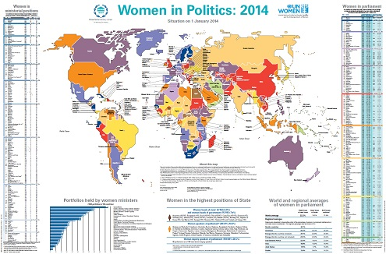
Station #4
Economics
Women comprise 70% of the world’s poorest people and own only 1% of the titled land.
Women tend to have less access to formal financial institutions and saving mechanisms. While 55 per cent of men report having an account at a formal financial institution, only 47 per cent of women do worldwide. This gap is largest among lower middle-income economies as well as in South Asia and the Middle East and North Africa
Women continue to participate in labour markets on an unequal basis with men. In 2013, the male employment-to-population ratio stood at 72.2 per cent, while the ratio for females was 47.1 per cent
Globally, women are paid less than men. Women in most countries earn on average only 60 to 75 per cent of men’s wages [9]. Contributing factors include the fact that women are more likely to be wage workers and unpaid family workers; that women are more likely to engage in low-productivity activities and to work in the informal sector, with less mobility to the formal sector than men; [10] the view of women as economic dependents; and the likelihood that women are in unorganized sectors or not represented in unions
Women bear disproportionate responsibility for unpaid care work. Women devote 1 to 3 hours more a day to housework than men; 2 to 10 times the amount of time a day to care (for children, elderly, and the sick), and 1 to 4 hours less a day to market activities [13]. In the European Union for example, 25 per cent of women report care and other family and personal responsibilities as the reason for not being in the labour force, versus only three per cent of men [14]. This directly and negatively impacts women’s participation in the labour force.
Gender differences in laws affect both developing and developed economies, and women in all regions. Almost 90 per cent of 143 economies studied have at least one legal difference restricting women’s economic opportunities [22]. Of those, 79 economies have laws that restrict the types of jobs that women can do [23]. And husbands can object to their wives working and prevent them from accepting jobs in 15 economies –

Station #5
Health Care
Globally, the maternal mortality ratio dropped by 45 per cent between 1990 and 2013, from 380 to 210 deaths per 100,000 live births. Worldwide, almost 300,000 women died in 2013 from causes related to pregnancy and childbirth. Maternal death is mostly preventable and much more needs to be done to provide care to pregnant women.
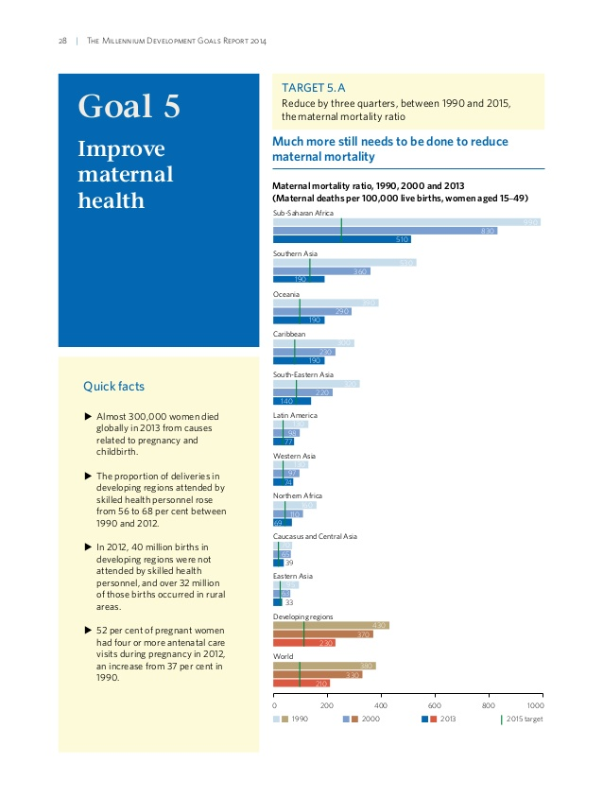
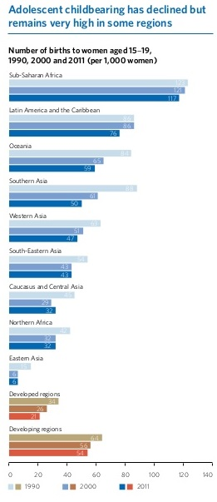

Station #6
Discriminatory laws and customs
Countries around the world have a variety of laws discriminating against women, ranging from age of marriage, nationality, freedom of movement to the right to divorce, work and retire under the same conditions as men. Many women face discrimination in relation to custody of children. Many countries’ laws still see the father as the legal guardian of the child. The mother, if she can, has to fight to gain custody. In many states, women also face restrictions in their freedom of movement. These discriminations usually refer to women not being allowed to move or travel without male company. Laws discriminating against women are practically endless.
In China for example, a One Child Policy mostly only permits Chinese couples to have 1 child. Since there is a custom of the male child carrying on the family name and taking care of the parents in their old age, Chinese families prefer to have a male child. Today, 118 males are born on average to every 100 males, compared to the global average of 103. This means that by 2020 there will be over 30-40 million males who will be unable to find female spouse.

Station #7
Education
